**Develop a Mobile Application**

|  |  |
| --- | --- |
| Date | 16 November 2022 |
| Team ID | PNT2022TMID33110 |
| Project Name | Project – Smart Farmer-IoT Enabled smart Farming Application |

**Creating Mobile app using MIT app Inventor**

**SMART FARMER APPLICATION**

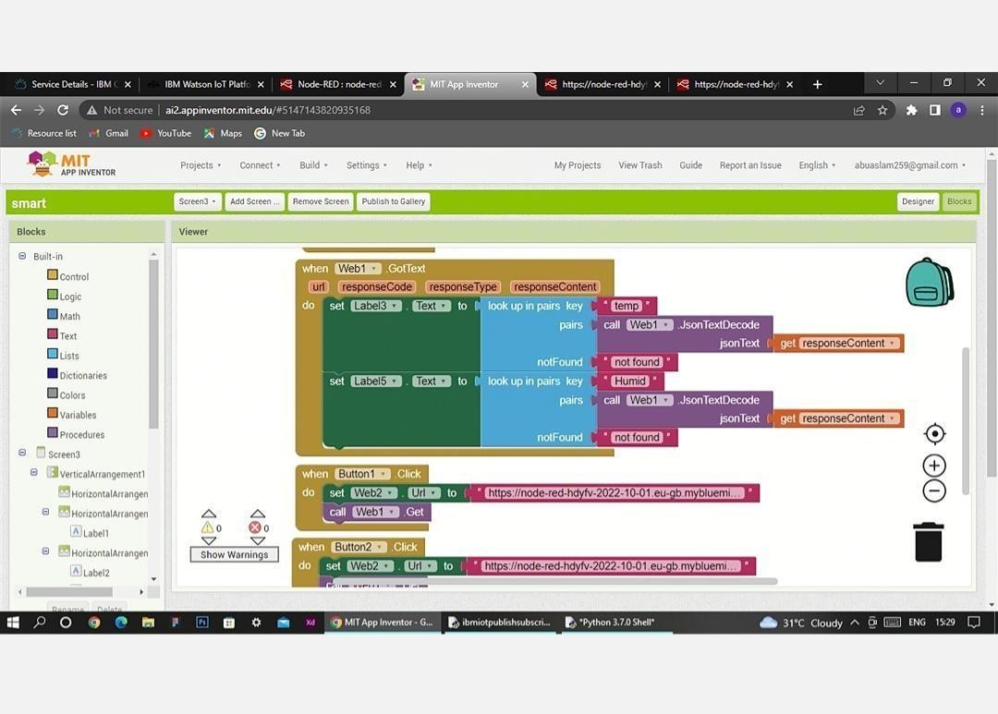**Blocks**

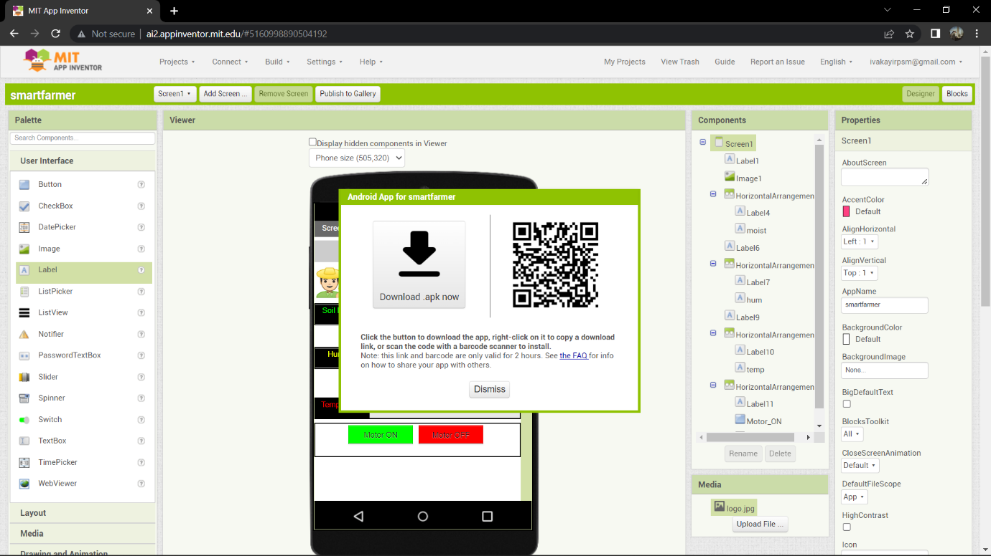**QR Code for APK download:**

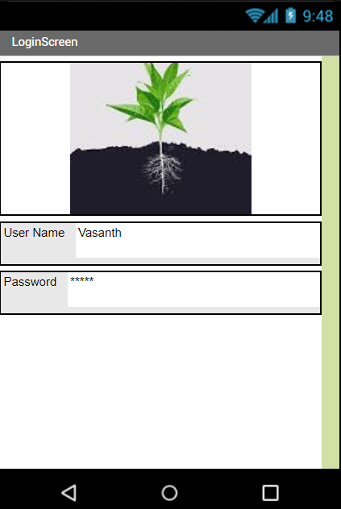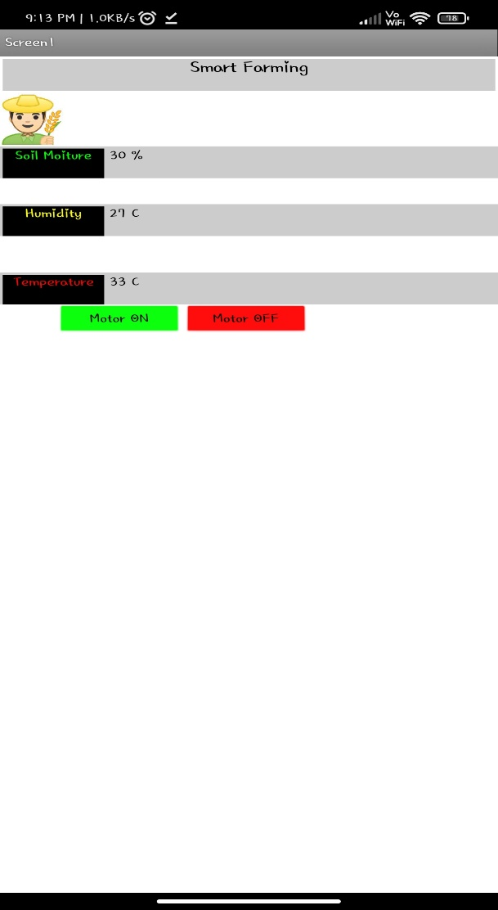 **Output Screen in Mobile :**